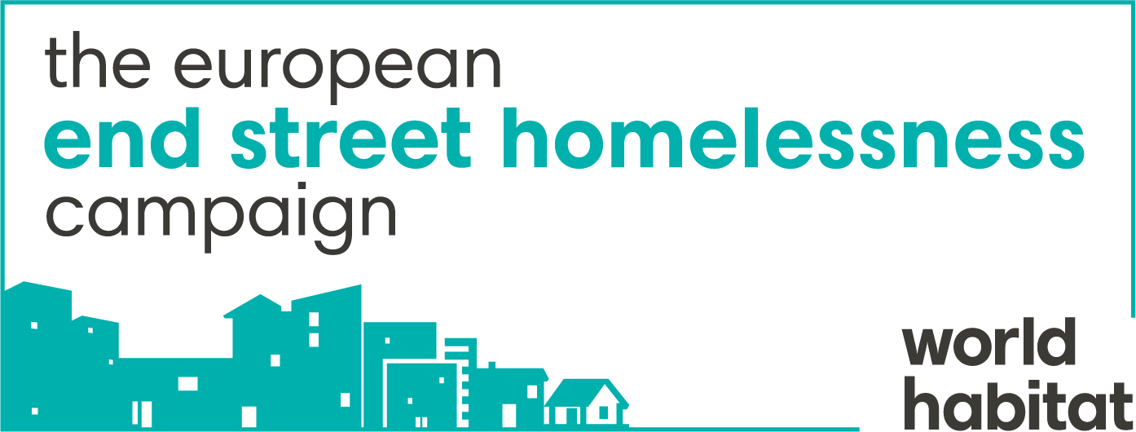

Media Permission Form:

I understand that the media team working with Galvanise and World Habitat will be using my image and story as part of their advocacy efforts to highlight the narratives of homeless people and the issues they face.

I support this advocacy and as part of this I am happy for my story and image to be used in these ways:

- In the internal publications of Galvanise and World Habitat ( )

- To be responsibly placed in media publications both in print and online ( )

- To be shown in galleries and exhibitions as large prints. ( )

(please note that none of these above are guaranteed)

If you are able to provide us with an email address or mobile phone number we will notify you of any publication :___________________________________________

I understand that I am not entitled to any payment or other compensation from World Habitat or anyone else for the permission granted in this permission form nor for the actual publication or use of my photograph or likeness.

Signed: ___________________________________________

Name (print): _______________________________________

Date: _____________________________________________

